### Dreaming of Santorini...A Windmill House

Santorini is a beautiful Greek island with white-washed houses with blue roofs. My husband and I went there a few years ago. I would love to return. In the meantime, I decided to recreate my memories by designing a windmill. This is my version without the wooden crossbeams because it would require more engineering that I am willing to do on this project. I would have to worry about the weight of the wooden crossbeams and how to attach it...so not today.

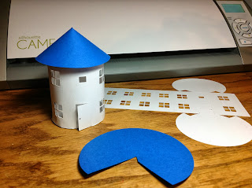Here is a picture with my previously designed house so that you can see the windmill in reference to size.

